https://www.stress.org/ptsd-in-personality-disorders-theory-part-1

PTSD in Personality Disorders (Theory – Part 1)
By Louise Gaston, PhD, FAIS
*This is an article from the Winter 2024 issue of Combat Stress
Introduction
From 1997 to 2007, I gave courses of continuing education to mental health professionals across the USA. In the course entitled PTSD and Personality Disorders, I asked participants if they employed the Diagnostic and Statistical Manual for Mental Disorders (DSM) to orient their therapeutic work with personality disorders (PD). Only one or two hands would be raised. Before 1995, I was in the same predicament. Indeed, the DSM has very little clinical value with PD.
In 1995, I turned to psychodynamic authors to better help my patients. Theoreticians had developed sophisticated theories and therapeutic approaches, particularly Dr. James Masterson and colleagues.1-6 At my clinic specialized in PTSD, I added the Masterson approach to an integrative psychotherapy for PTSD based on Horowitz’s model.7,8 We became able to respond to the needs and capacities of individuals presenting with various PDs. Our clinical effectiveness increased up to a 96% rate of PTSD remission, with 48% obtaining full remission.9 Over the last 30 years, we have treated more than 6,000 patients with PTSD.
DSM vs. Psychodynamic Diagnoses
For decades, the DSM defined PD according to Millon’s theory. This model defines PD according to the characteristic patterns of relationships, behaviors, affects, and cognitions displayed by individuals.10 From a psychodynamic perspective, however, most PD in the DSM are manifestations of defense mechanisms (e.g., obsessive-compulsive) and/or expressions of temperamental dispositions (e.g., histrionic).1-3 In this perspective, personality disorders are mostly disorders of the self (SD), which represent a broader category of individuals than PD.
Psychodynamic theoreticians conceptualize most SD as structural damages due to relational deficits experienced in infancy.1-6 Many employ the term “disorder of the self” to reflect the core realities at play in the self, mainly structural damages. To understand how PTSD operates in SD, let’s look at the possible damages to the self as caused by trauma.
Potential Damages to Self by Traumatic Events
Some PTSD theoreticians have claimed that PD is caused by traumatic events in childhood. In my opinion, such a stance arises from an excessive focus on traumatic events as determinants of psychological realities. Nonetheless, two concepts are important contributions to be considered, the internalized perpetrator and the reality of dissociative states.
Firstly, the concept of the internalized perpetrator was proposed by Herman who identified this structural damage in individuals who had been repeatedly victimized.11 Using precise control strategies of both threatening and rewarding, the perpetrator succeeds in taking over the agency of the victim via the mechanism of interjection. The perpetrator is thus internalized. The child first submits to the perpetrator’s demands and then anticipates them. The internalized perpetrator remains operative later in life, even long after the perpetrator’s death. 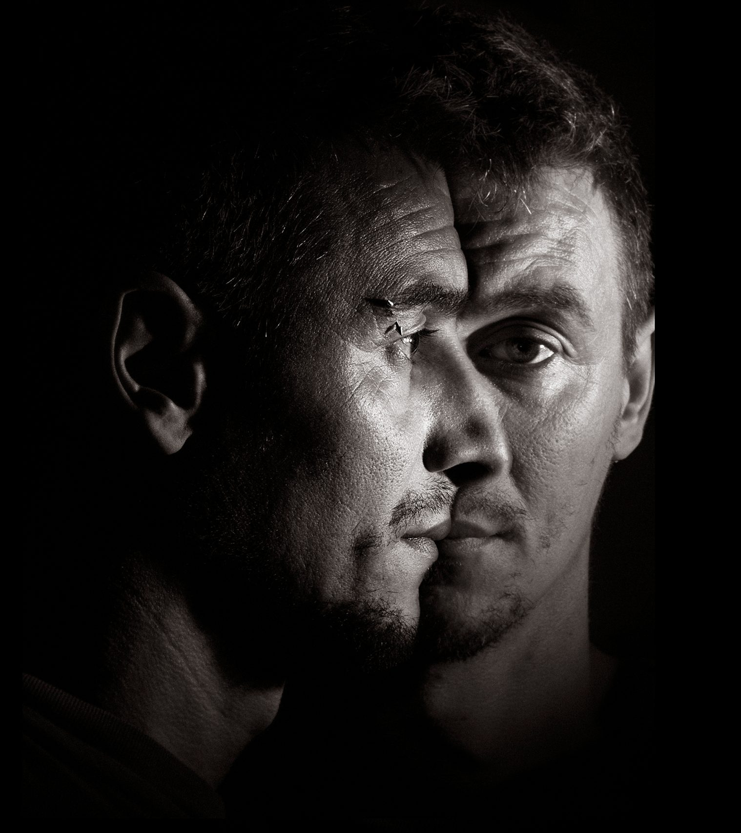
This concept is major because many individuals with SD have been abused by their parents. However, this concept cannot explain many phenomena at play in SD. First, the occurrence of repeated traumas in childhood cannot explain the various types of structural damages in SD (see below). Second, SD emerges very early in infancy, usually before the occurrence of any traumatic events. Third, only the concept of SD explains the presence of structural damages in childhood despite the absence of traumatic events. Fourth, the concept of SD emphasizes the need in psychotherapy to do character work as a holding structure before engaging in any trauma-focused work if ever.
Secondly, the identification of dissociation is major to understand possible consequences of traumatic events. Dissociation is a major defense mechanism present in early childhood and which can be triggered by traumatic events. Dissociation can induce severe emotional inhibition, but dissociative states can also be created. Beyond PTSD and SD, dissociative states correspond to closed-off areas of structural damages in the self. Orcutt explains the role of dissociative states in SD when trauma occurs in infancy.4-6
Responses to Traumatic Events
In the DSM-IV, to diagnose PTSD, clinicians had to consider the person’s reactions during the traumatic event; namely, overwhelming fear (annihilation anxiety), helplessness, and/or horror.12 I would add that traumatic events can also trigger an unbearable sense of aloneness, which is important to recognize to understand PTSD in SD. These experiences can usually be tolerated by well-structured individuals, but individuals with SD have a much harder time. Let’s see why.
Well-structured individuals have strong-enough ego capacities, such as affect regulation, mature defense mechanisms, and good-enough internalized objects. During a traumatic event, well-structured individuals can experience intense dysphoric affects, but they are less likely to become overwhelmed by them. Only very violent events will trigger PTSD in these people.
In contrast, individuals with SD develop PTSD irrespective of the intensity of the violence embedded in traumatic events. At my clinic, I found no correlation, none whatsoever, between the severity of PTSD and the intensity of the violence embedded in the traumatic event (r = 0.00) (unpublished). Obviously, something else is at play. Of interest, we noted that almost all our patients presented with SD.
For individuals with SD, a traumatic event can act as powerful stimulus reactivating the intense dysphoric affects associated with the emotional abandonment they experienced in infancy. Therefore, when they develop PTSD, individuals with SD end up struggling with a double whammy; they are bombarded by both PTSD symptoms and intense feelings of abandonment. In addition, they do not have the benefit of mature defense mechanisms to contain such intense affects. Consequently, their PTSD is severe to extreme, and their SD is amplified. To understand PTSD in SD, let’s first review psychodynamic models of trauma.
Psychodynamic Models of PTSD
In the last century, Fenichel proposed that trauma-related symptoms develop when current traumatic events revive infantile conflicts, which come to reflect the ways of feeling and defending in childhood.13 Freud stipulated that traumatic events lead to an excessive incursion of stimuli, overwhelming the psychic protective shield; the person is flooded with impulses and psychological functions are disrupted.14 More recently, Catherall combined these two approaches, delineating two types of traumas: a primary trauma as damages to one’s defence mechanisms and a secondary trauma as damages to one’s relations to internalized objects.15
These psychodynamic considerations are included in Horowitz’s model for PTSD.16 Trained by Horowitz during my post-doctoral studies, I embraced his theory and therapy model.17,18
PTSD Only – Trauma as Incongruent
Horowitz suggests that any significant experience, such as a traumatic event, needs to be integrated into the pre-existing psychic structure of the person. PTSD develops when an individual cannot integrate the traumatic experience due to an incongruency between the pre-existing self and the traumatized self.16
To resolve PTSD, Horowitz emphasizes that a person needs to voluntarily face the traumatic experience, but only at tolerable doses. In psychotherapy, the aspects of the pre-existing self-challenged by the traumatic event must be transformed into a more mature version, thus allowing the traumatic experience to be integrated. To do so, defense mechanisms need to be altered, the pre-existing conflicts reactivated by the traumatic experience need to be resolved, and one’s relations with some internal objects need to be transformed.16-18 Horowitz’s short-term therapy of 12 sessions can be very effective, but only for well-structured individuals. In SD, a different phenomenon is at play.
PTSD In SD – Trauma as Too Congruent
For individuals with SD, the traumatic experience leading to PTSD is too congruent with a part of the pre-existing self, namely, the real self. The traumatic experience resembles too much the unbearable emotional abandonment experienced in infancy.8 In SD, traumatic events can thus forcibly reactivate early feelings of abandonment, which can be overwhelming. To regain some control, the usual inadequate defense mechanisms at play are intensified, which amplifies SD. Consequently, psychotherapy of PTSD in SD must entail the consideration of all the structural damages. To do so, I have found the Masterson approach to be very helpful.8
Masterson Approach to SD
Masterson suggests that most SD will emerge when the infant meets with an unempathic wall from the significant caregiver, mostly the mother.1-3 Such lack of age-appropriate emotional response leaves the infant feeling emotionally abandoned. As basic psychological needs are left unanswered by the mother, the real self needs to be repressed. Consequently, a false self develops as an attempt to maintain the relationship with the mother and avoid physical abandonment.8 The characteristics of the false self will depend on the developmental stage at which the real self was left unanswered (see below). As emphasized by Orcutt, the various SD are a function of the developmental stages outlined by Mahler at which emotional abandonment occurs.4-6
Let’s note, however, that the Masterson approach also considers that some SD develop from the actual absence of the mother or the infant’s hypersensitive temperament. As suggested by Orcutt, because these infants end up having immature and underdeveloped psychological structures, feelings of rejection later in life easily become overwhelming and thus traumatic.16
Self Disorders
In addition to psychopathy, the Masterson approach identifies three basic SDs: schizoid, narcissistic, and borderline.1,6 For each SD, there are different levels of intensity (low, moderate, high), along with various levels of functioning (low, moderate, and high). For example, an individual displaying an intense SD with low functioning will usually cause trouble and be diagnosed as having a PD in the DSM. In contrast, a mild SD with high functioning will usually lead to a relatively flexible person, making it harder for clinicians to detect. Nonetheless, to be effective, clinicians need to tailor psychotherapy to any SD if one is at play.
The Masterson approach suggests that SD are diagnosed according to how one relates to oneself, others, and the world, along with the preferred defense mechanisms at play. We also need to know that any SD can use at times the preferred defense mechanism of another SD; for example, schizoids can act out, narcissists can cling, and borderlines can idealize. For a comprehensive description of SD with clinical examples, the reader is referred to The Unanswered Self by Orcutt (2021).6 For our purpose, let’s look at each SD briefly.
Psychopathic
Psychopathy is not conceptualized by the Masterson approach as SD per se developed from relational traumas in infancy. It is viewed as an incapacity to relate to others in an affective fashion, with compassion, and is neurologically determined. This conceptualization is amply supported by recent neuroimagery findings.19 Therefore, the Masterson approach considers psychopaths to be untreatable in psychotherapy.
Although they can be charming, psychopaths are basically manipulative and are out for themselves.20 The world theoretician on psychopathy, Dr. Robert Hare, best describes this phenomenon in Without A Conscience: The Disturbing World of Psychopaths Among Us.20 Briefly trained in his approach, I was able to protect my clinic and colleagues from being professionally abused by psychopaths coming to psychotherapy only to get compensation from agencies, quite willing to cause trouble.
Schizoid
A schizoid SD is formed in the first year of life; that is, when the infant requires both to be recognized as existing and to be welcomed as having basic needs. The infant yearns to be answered by the mother, who should be delighted to have the infant, but whose response instead is inhibited or misdirected (these mothers are often schizoid, dissociated, psychotic, psychopathic, or overwhelmed). Consequently, the infant’s basic needs residing in the real self are denied and thus repressed. A false self thus develops, focused on self-dismissal. The main defense mechanisms of schizoids are distancing and intellectualization, although schizoids can take refuge in their imaginary world where they are quite alive. Later in life, schizoids may appear as if they have no needs or emotions, and they are usually task-oriented and hard workers.
The Masterson approach identifies at least two types of false self in schizoids: compliant and avoidant. When the false self is compliant, the real self is in hiding and others are perceived as masters. When the false self is avoidant, the real self is in exile and others are perceived as sadistic and dangerous. In my experience, schizoids usually present both types of false self. Importantly, as the presence of extroversion can sometimes make a schizoid hard to detect, clinicians need to look at the quality of intimate relations to insure an adequate diagnosis. Psychotherapy can be helpful to schizoids and even resolve their SD. However, knowledge of this SD is crucial to avoid making serious mistakes such as focusing on emotions or self-affirmation. Psychotherapy can take years before becoming effective.
Narcissistic
A narcissistic SD develops between 10 and 18 months old; that is, when the infant starts to develop competencies (talking, crawling, walking, etc.) and needs to be seen as doing so. The infant is applauded by the mother and the father, whenever a competency is displayed. The problem begins when a demand is placed upon the infant to grow up faster than is age appropriate. Indeed, performance is required by the parents, and vulnerability is rejected. Those infants are only praised when they are competent, but they are criticized, if not ridiculed, when they show clumsiness or needfulness. In response, a false self develops, focused on performing. The main narcissistic defenses are idealizing and devaluing. In life, narcissists tend to push themselves beyond limits and reject vulnerabilities. They can develop impressive skills and achievements, or simply be excellent workers.
The Masterson approach identifies two types of false self in narcissists: manifest and closet. The manifest seeks to be admired, while the closet seeks to admire someone from whom to be approved. In my experience, most narcissists seek both to be admired and to admire, which makes them more flexible and thus more amenable to change in psychotherapy. Let’s note that clinicians may have difficulties detecting closet narcissists because these people are usually quite enjoyable, seeking to admire and please the psychotherapist. Psychotherapy can be helpful to narcissists if a sense of togetherness is first provided via empathy, which prepares the ground for later addressing against vulnerability and resolving conflicts.
Grandiosity can be easily recognized in the manifest narcissist, while it is hidden in the closet narcissist. In my view, grandiosity in the narcissistic SD is an attempt at perfection. Admiration and/or approval of one’s temporary perfection provides narcissists with a sense of togetherness, as it was in infancy when mother applauded new capacities. Therefore, narcissists are appeased whenever others appear to be perfectly aligned with them or when they feel that they are perfectly aligned with others.
Before closing, let’s emphasize that the narcissistic PD defined in the DSM is very different from the narcissistic SD. The DSM narcissist is fundamentally a psychopath according to Hare and cannot be compassionate.20 In contrast, the narcissist SD, as defined by the Masterson approach, presents a clear capacity for compassion. However, they can quickly lose respect for others if they perceive that they are being disagreed with or put down.
Borderline
A borderline SD develops between 1.5 to 3 years old; that is, when the child seeks independence from the mother while being reluctant to let go her reassurance. In this period of the “terrible twos,” the child needs to be supported towards independence, while appropriate limits are set at the same time. However, in the borderline distortion of development, the mother excessively clings onto her child and/or responds with rigid disapproval to the child’s strides toward independence (such mothers often present with a borderline SD themselves). Because the child’s needs have been sufficiently met by the mother earlier, enough inner strength has been developed in the infant to permit an active struggling with the mother. This struggle is between urges for autonomy and still a need for dependency. The main defense mechanisms of borderlines are clinging and fighting (clinging by fighting). Later in life, borderlines oscillate between reserved accomplishments and passivity. As a result, they usually develop limited capacities, avoiding success and/or task completion.
The Masterson approach identifies at least two types of false self in borderlines: hostile and clinging. Hostile borderlines cling onto others by starting arguments, sometimes insanely intense arguments. Dependent borderlines cling onto others by presenting themselves as helpless and needy. When borderlines are faced with separation, even if it is temporary, they can resort to self-destructive acting-out in an attempt to force others to take charge of them. However, some borderlines also stubbornly cling by quietly hiding in a bedroom at the parents’ house. Borderlines often dramatically alternate between these states, giving them the reputation for being emotionally labile. Often lively and enjoyable in their real self, the false self of the borderline can suddenly become a troublemaker demanding hospitalization. Surprisingly, given their capacity to struggle, borderlines have way more capacities than they think they have (and that clinicians think they have). Masterson developed an impressively effective approach to help borderlines, even severely acting-out teenagers, using reality-based confrontations.
At my clinic, Veterans with PTSD have mostly presented a narcissistic or schizoid SD, along with dissociative states. Nonetheless, surprisingly, a few presented a borderline SD. Given the intensity of the traumatic events, their PTSD and SD were both severe to extreme.
Abandonment Depression In SD
The psychological structure of SD is built by the psyche to avoid abandonment depression. To ensure the continuity of such avoidance, individuals are caught in a vicious cycle, called the Masterson triad.1-3 To understand this triad, let’s first remember that all humans have an inherent tendency to self-activate, that is, to act according to one’s basic needs in favor of one’s development. The tendency to self-activation resides in the real self. In all SD, a basic conflict exists between the need to self-activate and the need to avoid abandonment depression.
The Masterson triad is composed of three positions: self-activation, abandonment anxiety, and a return to defense mechanisms. Whenever a person with SD self-activates, abandonment anxiety emerges to alert against the possibility of abandonment depression, forcing a return to the defenses employed by the false self. If a person with SD perseveres into self-activation and tolerates abandonment anxiety, this person could escape this vicious cycle and its related SD. However, this person would fall into abandonment depression, which can be horrendous.
Abandonment depression corresponds to the experience of a total void, along with feelings of rage, helplessness, meaninglessness, and despair. Abandonment depression involves suicidal thoughts and, untreated, may even lead to suicide. However, psychotherapy can help by offering a relationship in which abandonment depression can be experienced without being left alone, abandoned. Working through abandonment depression is challenging for both patients and clinicians, but the hard-won results are worth the risks and the pain.
Conclusion
Individuals with SD are likely to seek psychotherapy when PTSD emerges. Counterintuitively, this is an opportunity. Indeed, the real self is now piercing through the wall of the false self via some PTSD symptoms, and the real self is more accessible whenever feelings of abandonment emerge. Although challenging, working through abandonment depression is the only doorway to free oneself from SD and oftentimes from PTSD.
A well-informed and well-performed psychotherapy can induce the resolution of both SD and PTSD. For such a major transformation to occur, clinicians need to be knowledgeable. Clinicians need to be able to identify the specific SD at play and provide a psychotherapy tailored to the patient’s needs and capacities. Clinicians need to be solid, reliable, responsive, and benevolent, without wavering into countertransference. Such work can only be accomplished at a tolerable dosage. Part 2 of this article will present this specialized psychotherapeutic endeavour.
References
- Masterson, J.F. (1985). The real self: A developmental, self, and object relations approach. New York: Brunner/Mazel.
- Masterson, J.F., & Klein, R. (Eds.) (1989). Psychotherapy of the Disorders of the Self: The Masterson Approach. New York: Brunner/Mazel.
- Masterson, J.F., & Klein, R. (Eds.) (1995). Disorders of the self, new therapeutic horizons: The Masterson approach. New York: Brunner/Mazel.
- Orcutt, C. (1995). The influence of early trauma on the developing self. In J.F. Masterson, & R. Klein (Eds.) Disorders of the self, new therapeutic horizons: The Masterson approach (pp. 181-254). New York: Brunner/Mazel.
- Orcutt, C. (2012). Trauma in Personality Disorder: A Clinician’s Handbook. The Masterson Approach. Bloomington, IN: Author House.
- Orcutt, C. (2021). The Unanswered Self: The Masterson Approach to the Healing of Personality Disorders. London, UK: KARNAC.
- Gaston, L. (1995). Dynamic therapy for post-traumatic stress disorder. In J. P. Barber and P. Crits-Christoph (Eds.), Dynamic therapies for psychiatric disorders (Axis I) (pp. 161-192). New York: Guilford Press.
- Gaston, L. (2017). PTSD and Personality Disorders. Unpublished document available as a free pdf at www.traumatys.com.
- Brunet, A. (2004). Étude préliminaire de 100 dossiers de TRAUMATYS pour une étude prospective des corrélats neurologiques des changements symptomatiques de l’ÉSPT. Department of Psychiatry, McGill University, Douglas Institute, 6875 boul. LaSalle, Montréal (QC), Canada H4H 1R3
- Millon, T, & Everly, G.S. (1985). Personality and Its Disorders: A Biosocial Learning Approach. NewYork: Wiley.
- Herman, J.L. (1992). Complex PTSD: A syndrome in survivors of prolonged and repeated trauma. Journal of Traumatic Stress, 5, 377-391.
- American Psychiatric Association (1994). The Diagnostic and Statistical Manual for Mental Disorders, 4th Edition: DSM-IV. Washington DC, American Psychiatric Association Press.
- Fenichel, O. (1945). The psychoanalytic theory of neurosis. New York: Norton.
- Freud, S. (1953). Moses and monotheism. In J. Strachey (Ed.), The standard edition of the complete psychological works of Sigmund Freud (Vol. 23, pp. 7-53). London: Hogarth Press.
- Catherall, D.R. (1991). Aggression and projective identification in the treatment of victims. Psychotherapy, 28, 145-149.
- Horowitz, M.J. (1976, 1984, 2001). Stress Response Syndrome. New York: Jason Aronson.
- Horowitz, M.J., & Kaltreider, N. (1979). Brief psychotherapy of the stress response syndrome. Psychiatric Clinics of North America, 2, 365-377.
- Horowitz, M.J. (1984). Brief Dynamic Psychotherapy and Character Styles. New York: Jason Aronson.
- Nummenmaa, L., Lukkarinen, L., SunL. (2021). Brain Basis of Psychopathy in Criminal Offenders and General Population. Cerebral Cortex, DOI: 10.1093/cercor/bhab072
- Hare, R.D. (1993). Without Conscience: The Disturbing World of Psychopaths Among Us. New York: Guilford Press.

ABOUT THE AUTHOR
Dr. Louise Gaston, PhD in psychology, has founded in 1990 a clinic specialized in Post-Traumatic Stress Disorder, TRAUMATYS, in Canada, where she developed an integrative model for treating PTSD, which is flexible and open-ended. In addition, she elaborated a comprehensive 2-year training program in PTSD and trained more than 200 experienced clinicians in evaluating and treating PTSD. Thousands of individuals presenting with PTSD and comorbidity have been treated with this integrative model for PTSD. According to an independent and retrospective study, the associated PTSD remission rate is 96%: 48% complete and 48% partial. Dr. Gaston is the author of several book chapters and more than 40 scientific/clinical articles.
Since 1980, Dr. Gaston has been practicing psychotherapy. She has been trained and supervised over 15 years. She knows all major models of psychotherapy (dynamic, humanistic, cognitive, and behavioral) and has been trained over 5 years in treating personality disorders.
As a clinical researcher, Dr. Gaston collaborated with many colleagues in diverse settings. She has carried out two clinical trials. Her main research topic was the alliance in psychotherapy and its interaction with techniques as they contribute to better outcomes. In collaboration with Dr. Marmar, MD, she has developed the California Psychotherapy Alliance Scale, CALPAS, a measure of the alliance in psychotherapy which is worldly used.
In 1988, Dr. Gaston completed a 2-year postdoctoral fellowship in PTSD and psychotherapy research, at the Langley Porter Psychiatric Institute, University of California, San Francisco, under the supervision of Dr. Horowitz, M.D., author of Stress Response Syndrome, and Dr. Marmar, MD, both ex-presidents of the International Society for Psychotherapy Research and the International Society for Traumatic Stress Studies. Afterwards, she was assistant professor in the Department of psychiatry at McGill University in Canada from 1988 to 1994. Dr. Gaston elaborated scales on the MMPI-2 to assess PTSD in civilians.
For many years, Dr. Gaston has provided courses of continuing education across the USA: Integrating Treatments for PTSD, Trauma and Personality Disorders, Memories of Abuse and the Abuse of Memory, and Ethics Working for You. Nowadays she writes, trains, and supervises on PTSD.

Combat Stress Magazine

